Copulas: USDJPY and EURGBP
Method 18 / daily log returns / empirical ranks / Gaussian + Clayton / Alpari D1 full available history

Study setup
Logical pair: USDJPY , EURGBP
Broker symbols: USDJPY_i , EURGBP_i
Snapshot: 2026-11-03_majors_alpari_D1
Timeframe: D1
Matched return window: 1999-01-06 to 2026-11-02 (UTC bar dates)
Matched return count n: 7181
Dropped unfinished last bar dated 2026-11-03 UTC after a tick-volume check against the prior complete day.
Margins: empirical ranks / (n+1)
Families: Gaussian (rho) and Clayton (theta), fixed before ranking
Complete matched rows (Excel): USDJPY-EURGBP_Copula_D1.xlsx
Complete matched rows (HTML table): USDJPY-EURGBP_Copula_D1_data.html

Method carried forward
Copulas separate marginal return shapes from dependence on the unit square. Matched daily log returns of close, ln(close_t / close_t-1), are mapped to pseudo-observations u_i = rank(x_i)/(n+1) and v_i = rank(y_i)/(n+1). A Gaussian copula parameter rho is the Pearson correlation of Phi^{-1}(u) and Phi^{-1}(v). A Clayton copula theta >= 0 is fit by maximum likelihood on (u,v) for lower-tail asymmetry. Quotes are not inverted. Kendall tau implied by each fit and Spearman of (u,v) are stored. Same-sample Pearson r on returns is a side check. This is not causation and not a trading signal.

Results
Gaussian rho: -0.118291
Gaussian Kendall tau: -0.075483
Clayton theta: 0.000000
Clayton Kendall tau: 0.000000
Spearman of (u,v): -0.109100
Pearson r on returns: -0.127992

Conclusion
Over 7181 matched daily rows for USDJPY and EURGBP, Gaussian copula rho = -0.1183 (Kendall=-0.0755) and Clayton theta = 0.0000 (Kendall=0.0000). Spearman of (u,v) = -0.1091; Pearson r on returns = -0.1280. This is not causation and not a trading signal.

Charts
Daily closes

Daily log returns

Pseudo-observations (u,v)
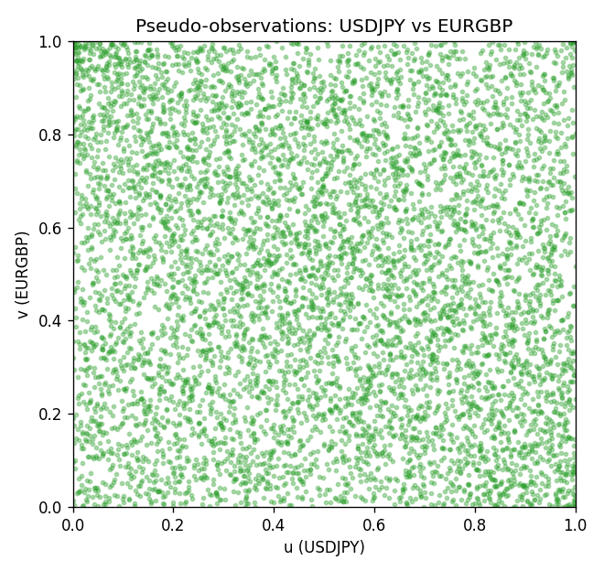

Data report
Every matched row is stored in the sibling Excel workbook named USDJPY-EURGBP_Copula_D1.xlsx, including u and v. Embedding all rows as a Word table is impractical; this file holds column summaries and the first and last 15 matched rows.
Columns: time, USDJPY_open, EURGBP_open, USDJPY_high, EURGBP_high, USDJPY_low, EURGBP_low, USDJPY_close, EURGBP_close, USDJPY_tick_volume, EURGBP_tick_volume, USDJPY_spread, EURGBP_spread, USDJPY_real_volume, EURGBP_real_volume, USDJPY_log_return, EURGBP_log_return, u, v
Column summaries (matched calculation rows)
column | count | mean | std | min | 25% | 50% | 75% | max
USDJPY_open | 7181 | 113.80773 | 19.228846 | 75.693 | 104.38 | 110.98 | 120.71 | 163.824
EURGBP_open | 7181 | 0.78701429 | 0.09663819 | 0.5734 | 0.6877 | 0.83392 | 0.86523 | 0.9769
USDJPY_high | 7181 | 114.30513 | 19.290536 | 76.001 | 104.865 | 111.439 | 121.27 | 163.978
EURGBP_high | 7181 | 0.79009197 | 0.09701345 | 0.5789 | 0.6897 | 0.83701 | 0.8681 | 0.9799
USDJPY_low | 7181 | 113.28458 | 19.156841 | 75.402 | 103.87 | 110.53 | 120.172 | 163.628
EURGBP_low | 7181 | 0.78431381 | 0.09645598 | 0.5682 | 0.6857 | 0.83166 | 0.86287 | 0.9661
USDJPY_close | 7181 | 113.82069 | 19.244339 | 75.811 | 104.38 | 111.015 | 120.695 | 163.851
EURGBP_close | 7181 | 0.78705735 | 0.09663932 | 0.5735 | 0.6878 | 0.83401 | 0.86539 | 0.977
USDJPY_tick_volume | 7181 | 106398.86 | 179473.16 | 149 | 9958 | 53207 | 92916 | 1803508
EURGBP_tick_volume | 7181 | 87156.048 | 145513.65 | 154 | 6593 | 44384 | 81451 | 1424684
USDJPY_spread | 7181 | 20.250104 | 17.60648 | 0 | 6 | 11 | 30 | 50
EURGBP_spread | 7181 | 21.316669 | 19.115948 | 0 | 4 | 13 | 40 | 50
USDJPY_real_volume | 7181 | 3.4800425e+10 | 1.6097887e+11 | 0 | 0 | 0 | 0 | 3.8834203e+12
EURGBP_real_volume | 7181 | 2.788005e+10 | 1.3523257e+11 | 0 | 0 | 0 | 0 | 3.5726265e+12
USDJPY_log_return | 7181 | 4.847e-05 | 0.00620794 | -0.03908203 | -0.00320533 | 0.00011473 | 0.00340924 | 0.05184024
EURGBP_log_return | 7181 | 2.133e-05 | 0.00487349 | -0.03067367 | -0.00262366 | -0.00010035 | 0.00255918 | 0.06075387
u | 7181 | 0.5 | 0.28865503 | 0.00013924 | 0.25006962 | 0.5 | 0.74993038 | 0.99986076
v | 7181 | 0.5 | 0.28865499 | 0.00013924 | 0.25006962 | 0.5 | 0.74993038 | 0.99986076
First 15 matched rows (selected columns)
time | USDJPY_log_return | EURGBP_log_return | u | v
1999-01-06 | 0.0075660159 | -0.013303338 | 0.91172375 | 0.0080757449
1999-01-07 | -0.012851583 | 0.011051402 | 0.023252576 | 0.98217767
1999-01-08 | -0.0047719894 | -0.004943862 | 0.16861598 | 0.11946533
1999-01-11 | -0.016195423 | -0.0012752393 | 0.01336675 | 0.37468672
1999-01-12 | 0.032310364 | 0.0033970309 | 0.99958229 | 0.80214425
1999-01-13 | 0.0081373171 | 0.00042381861 | 0.92481203 | 0.55040379
1999-01-14 | 0 | -0.0019793588 | 0.48739905 | 0.30813144
1999-01-15 | 0.0055343401 | -0.0076715819 | 0.85171261 | 0.048593706
1999-01-18 | 8.7600193e-05 | 0.00071280921 | 0.4973545 | 0.58061821
1999-01-19 | -0.0056219403 | -0.0014261269 | 0.13951546 | 0.3614592
1999-01-20 | -0.0053879917 | 0.0019960086 | 0.14661654 | 0.70607073
1999-01-21 | 0.0084664056 | -0.00071240297 | 0.92940685 | 0.43191312
1999-01-22 | 0.0060412564 | -0.0017118406 | 0.86939571 | 0.33166249
1999-01-25 | -0.0073594164 | -0.0054402425 | 0.092174882 | 0.10150376
1999-01-26 | 0.0012303367 | -0.00057438255 | 0.59774436 | 0.44890003
Last 15 matched rows (selected columns)
time | USDJPY_log_return | EURGBP_log_return | u | v
2026-10-13 | -0.0018932826 | 0.00020130374 | 0.32804233 | 0.53077137
2026-10-14 | 7.5800166e-05 | 0.0011241873 | 0.49554442 | 0.62364244
2026-10-15 | -0.0018524319 | -0.00087557391 | 0.3309663 | 0.41283765
2026-10-16 | -0.00037976126 | -0.0020380844 | 0.4502924 | 0.30297967
2026-10-19 | 0.0034946841 | -0.00056950988 | 0.75494291 | 0.44959621
2026-10-20 | -0.0022546642 | -0.0035906254 | 0.30409357 | 0.18615984
2026-10-21 | -0.00032883504 | -0.00140647 | 0.45627959 | 0.36285157
2026-10-22 | -0.0085942669 | -0.0018743924 | 0.066694514 | 0.31704261
2026-10-23 | 0.00035080446 | 0.00082421033 | 0.52172097 | 0.59259259
2026-10-26 | 0.0041238746 | 0.00013133309 | 0.79156224 | 0.52227792
2026-10-27 | 0.0027651658 | -0.0019957343 | 0.71150097 | 0.30687831
2026-10-28 | -0.00095679538 | 0.00066967224 | 0.398357 | 0.57741576
2026-10-29 | -0.00038043789 | -0.0011722209 | 0.45015316 | 0.38415483
2026-10-30 | -0.0010596481 | -0.0024205543 | 0.39181287 | 0.2684489
2026-11-02 | 0.0026438521 | 0.00089940465 | 0.70328599 | 0.60094681

